**KLE Society's**

**KLE Technological University**

**Minor Project Report**

**On**

**Post Harvest loss in Agriculture using Blockchain**

**Submitted By**

### Pratham SHIROL 01FE21BCI018

SHRAVAN B S 01FE21BCI023

YASH S H 01FE21BCI005

School of Computer Science and Engineering

Vidyanagar, Hubballi – 580031, India.

Academic year 2023-24

**ABSTRACT**

Agricultural food loss in the supply chain threatens food security and sustainability. This report identifies key inefficiencies, including inadequate infrastructure, poor storage, and logistical bottlenecks, through literature reviews, case studies, and surveys. Implementing advanced techniques like real-time tracking, optimized routing, and better storage can significantly reduce losses. These findings are vital for supply chain managers, policymakers, and technology developers, highlighting the need for innovative solutions and collaboration to enhance efficiency and sustainability in the agricultural sector.

**CONTENTS**

|  |  |  |
| --- | --- | --- |
| **Chapter No.** | **Title** | **Page No.** |
|  | **Introduction** | **4** |
|  | **Literature Review** | **5-6** |
|  | **Proposed Work** | **7** |
|  | **Results and Discussion** | **10-16** |
|  | **Conclusion** | **16** |
| **6. References** | | **17** |
|  | |  |

**INTRODUCTION**

Blockchain technology, also known as distributed ledger technology (DLT), is a revolutionary innovation that enables the secure, transparent, and decentralized recording of transactions across multiple computers. It is a digital ledger of transactions that is duplicated and distributed across the entire network of computer systems on the blockchain. Each block in the chain contains a number of transactions, and every time a new transaction occurs on the blockchain, a record of that transaction is added to every participant's ledger. This decentralized database is managed by multiple participants, known as nodes, which makes it inherently secure and resistant to tampering.

The implementation of blockchain technology in various domains has been driven by its potential to provide increased transparency, enhanced security, and improved efficiency in transaction processing. In the context of supply chain management, blockchain technology offers the ability to track the provenance and movement of goods with unparalleled accuracy. This capability is particularly beneficial in addressing the challenges associated with agricultural food loss, where inefficiencies and lack of transparency contribute significantly to the problem. By leveraging blockchain technology, stakeholders can achieve better visibility and coordination across the supply chain, thereby mitigating losses and enhancing overall performance.

The motivation for addressing agricultural food loss within the supply chain using blockchain technology stems from the urgent need to improve food security, economic stability, and environmental sustainability. As the global population continues to grow, the demand for food increases, necessitating more efficient and reliable supply chain management practices. Despite advances in agricultural techniques, a significant amount of food is still lost before reaching consumers due to various inefficiencies in the supply chain. This not only exacerbates hunger but also leads to substantial economic and environmental costs. Implementing blockchain technology can help address these inefficiencies by providing a transparent and secure way to monitor and manage the supply chain, thus reducing food loss and enhancing the overall efficiency of food distribution.

**LITERATURE REVIEW**

[1] FAO. (2019). The State of Food and Agriculture 2019: Moving Forward on Food Loss and Waste Reduction.The FAO report offers a comprehensive overview of the global status of food loss and waste reduction efforts. It emphasizes the need for proactive measures to address inefficiencies throughout the food supply chain, from production to consumption. By identifying critical areas for intervention and highlighting best practices, the report serves as a foundational resource for policymakers, researchers, and practitioners seeking to combat food loss and waste.

[2] Devin, B., & Richards, C. (2018). Food Waste, Power, and Corporate Food Governance. *Third World Quarterly*, 39(2), 229-245.Devin and Richards delve into the socio-political dynamics of food waste within the context of corporate food governance. The study sheds light on power structures and vested interests that perpetuate food waste throughout the supply chain. By examining the role of corporate actors in shaping food governance regimes, the study underscores the importance of addressing underlying power imbalances to effectively tackle food loss and waste at a systemic level.

[3] Venkat, K. (2011). The Climate Change and Economic Impacts of Food Waste in the United States. *International Journal on Food System Dynamics*, 2(4), 431-446.Venkat's study investigates the environmental and economic ramifications of food waste in the United States, particularly in relation to climate change. The research underscores the significant carbon footprint associated with wasted food and its implications for greenhouse gas emissions. By quantifying the economic costs of food waste, the study provides valuable insights into the potential benefits of reducing food loss and waste for both the economy and the environment.

[4] FAO, IFAD, UNICEF, WFP, & WHO. (2020). The State of Food Security and Nutrition in the World 2020.This joint report by multiple international organizations provides a comprehensive assessment of global food security and nutrition trends. While not explicitly focused on food loss, the report contextualizes food loss within broader discussions of food security, malnutrition, and poverty. By emphasizing the interconnected nature of these challenges, the report underscores the importance of addressing food loss as part of holistic efforts to improve food systems and promote sustainable development.

[5] Casado-Vara, R., Prieto, J., De la Prieta, F., & Corchado, J. M. (2018). How Blockchain Improves the Supply Chain: Case Study Alimentary Supply Chain. *Procedia Computer Science*, 134, 393-398.Casado-Vara et al. present a case study on the application of blockchain technology to enhance transparency and efficiency in the alimentary supply chain. The study demonstrates how blockchain can improve traceability, reduce food fraud, and optimize supply chain operations. By showcasing practical examples of blockchain implementation, the research highlights the potential of emerging technologies to mitigate food loss and enhance trust throughout the supply chain.

[6] Tian, F. (2016). An Agri-Food Supply Chain Traceability System for China Based on RFID and Blockchain Technology. In *2016 13th International Conference on Service Systems and Service Management (ICSSSM)*.Tian's study explores the development of a traceability system for the agri-food supply chain in China using RFID and blockchain technology. The research demonstrates how these technologies can enhance transparency, traceability, and accountability in food supply chains, thereby reducing the risk of food loss and fraud. By leveraging RFID and blockchain, the proposed system provides real-time monitoring and verification of food products from farm to fork, offering valuable insights for improving supply chain management practices.

[7] Pearson, S., May, D., Leontidis, G., Swainson, M., Brewer, S., Bidaut, L., ... & Zisman, A. (2019). Are Distributed Ledger Technologies the Panacea for Food Fraud? *Foods*, 8(7), 210.Pearson et al. critically examine the potential of distributed ledger technologies, such as blockchain, to combat food fraud. The study assesses the strengths and limitations of blockchain in enhancing transparency and trustworthiness in food supply chains. By analyzing case studies and existing literature, the research provides valuable insights into the applicability of distributed ledger technologies as tools for mitigating food loss and improving food safety.

**PROPOSED WORK**

**Flow Diagram**

**:**

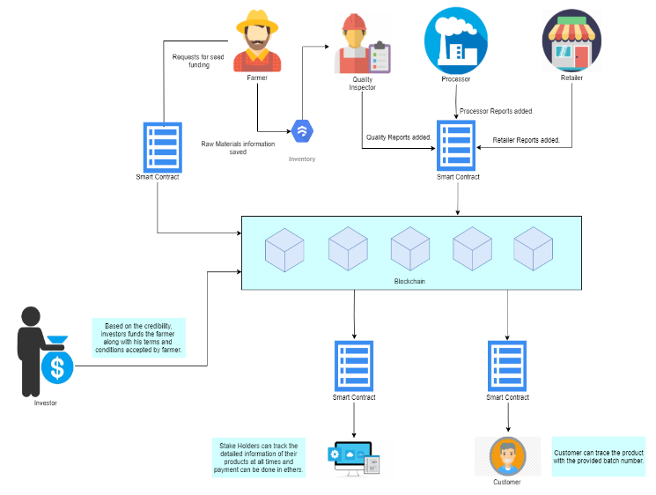

The proposed blockchain-based system revolutionizes the agricultural supply chain by enhancing transparency, traceability, and accountability. Farmers initiate the process by requesting seed funding from investors through smart contracts that include their credentials and proposed terms. Upon approval and funding, the farmer records raw material information, which is then verified by a quality inspector. This verified data, along with subsequent reports from the processor and retailer, is securely stored on the blockchain using smart contracts. Stakeholders can access detailed product information at any time, ensuring transparency and enabling payments in digital currencies. Finally, customers can trace the product's journey using batch numbers, ensuring authenticity and quality.

**Use Case Diagram:**

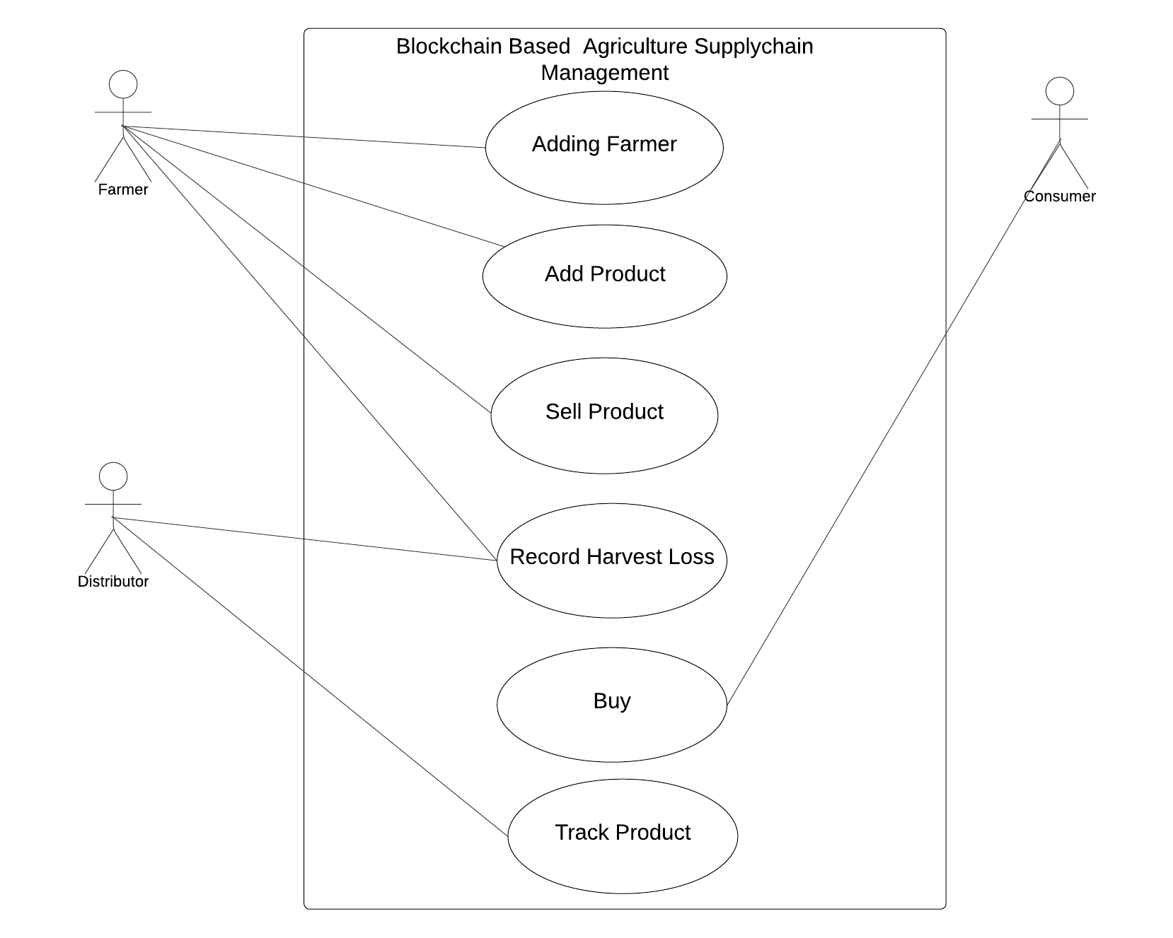

The use case diagram represents the interactions between different actors—Farmer, Distributor, and Consumer—and the functionalities provided by the Blockchain-Based Agriculture Supply Chain Management system. Farmers can register themselves in the system through the "Adding Farmer" use case, which involves providing necessary details to get added to the blockchain network. Once registered, farmers can add new products by specifying details such as name, quantity, and price via the "Add Product" use case. They can sell their products to consumers or distributors through the "Sell Product" use case, which updates the product's status on the blockchain. Additionally, farmers can record any post-harvest losses using the "Record Harvest Loss" use case to maintain accurate inventory records. Distributors, on the other hand, can also record losses during handling or transportation, purchase products from farmers, and track products throughout the supply chain using the "Record Harvest Loss," "Buy," and "Track Product" use cases respectively. Consumers can directly purchase products from farmers through the "Buy" use case and trace the origin and journey of the products they buy using the "Track Product" use case. This system ensures that all transactions and records are securely and transparently managed on the blockchain, enhancing trust and efficiency in the agricultural supply chain

**Frontend Integration:**

The frontend application provides a user-friendly interface for interacting with the Ethereum blockchain and the AgricultureSupplyChain smart contract. The frontend uses web3.js, a JavaScript library, to facilitate this interaction. The integration process involves several key steps:

1. **MetaMask Integration**: MetaMask, a popular Ethereum wallet browser extension, manages user accounts and handles transaction confirmations. When a farmer, distributor, or consumer interacts with the system (e.g., adding a product, buying a product), MetaMask prompts the user to confirm the transaction. The user inputs the necessary details and confirms the transaction.
2. **Transaction Submission**: MetaMask sends the transaction to the Ethereum network, invoking the relevant function of the deployed AgricultureSupplyChain contract. The transaction includes all necessary details, such as product information or purchase details, and the corresponding Ether if applicable.
3. **Event Listening**: The frontend application listens for specific events emitted by the smart contract, such as FarmerAdded, ProductAdded, ProductSold, and PostHarvestLossRecorded. When these events are detected, the frontend updates the user interface to reflect the changes and log the details.

**Deployment and Execution:**

The deployment and execution process involves setting up the necessary infrastructure to run the smart contract on the Ethereum blockchain. This includes the following steps:

1. **Geth and Mining Account**: The contract is deployed using Geth, an Ethereum client. A mining account in Geth is configured to deploy the smart contract and mine transactions, ensuring that the contract is properly recorded on the blockchain and that transactions are confirmed.
2. **Contract Deployment**: The smart contract is compiled and deployed to the Ethereum blockchain using the mining account. Once deployed, the contract’s address is recorded and used by the frontend application to interact with the contract.
3. **Frontend Connection**: The frontend application connects to the Geth node, enabling interaction with the deployed smart contract. When a user (farmer, distributor, or consumer) performs an action such as adding a product or buying a product, the frontend constructs the transaction and passes it to MetaMask for confirmation. Upon confirmation, the transaction is sent to the Ethereum network, where it is processed and recorded on the blockchain.

**RESULTS AND DISCUSSION**

The Agriculture Supply Chain platform is designed to be a secure, transparent, and efficient way to manage and track agricultural products from farmers to consumers. Below is a detailed breakdown of the system's model, including the smart contract components, frontend integration, and deployment process.

### System Model

#### Solidity Smart Contract

The core of the platform is the Solidity smart contract, which handles the recording and tracking of products on the Ethereum blockchain. The smart contract includes the following elements:

1. **Struct: Farmer**
   * Represents an individual farmer.
   * Attributes:
     + name: string (farmer's name)
     + farmerAddress: address (Ethereum address of the farmer)
     + isRegistered: bool (registration status of the farmer)
2. **Struct: Product**
   * Represents a product in the supply chain.
   * Attributes:
     + name: string (product's name)
     + quantity: uint (quantity of the product)
     + price: uint (price per unit of the product)
     + farmerAddress: address (Ethereum address of the farmer)
     + isAvailable: bool (availability status of the product)
3. **Mappings**
   * farmers: Maps farmer addresses to Farmer structs for efficient tracking.
   * products: Maps product IDs to Product structs for efficient tracking.
4. **Events**
   * FarmerAdded: Emitted whenever a farmer is registered.
   * ProductAdded: Emitted whenever a product is added by a farmer.
   * ProductSold: Emitted whenever a product is sold.
   * PostHarvestLossRecorded: Emitted whenever post-harvest loss is recorded.

#### Smart Contract Functions

1. **Add Farmer Function**
   * Adds a new farmer to the system.
   * Parameters: _farmerAddress, _name.
   * Checks that the farmer is not already registered, then creates a new Farmer struct and emits the FarmerAdded event.
2. **Add Product Function**
   * Allows registered farmers to add new products.
   * Parameters: _productId, _name, _quantity, _price.
   * Checks that the product ID is unique and the quantity and price are greater than zero, then creates a new Product struct and emits the ProductAdded event.
3. **Sell Product Function**
   * Allows customers to purchase products.
   * Parameters: _productId, _quantity.
   * Checks that the product is available and the quantity is sufficient. Transfers the appropriate amount of Ether to the farmer and emits the ProductSold event.
4. **Record Post-Harvest Loss Function**
   * Allows farmers to record post-harvest losses.
   * Parameters: _productId, _lostQuantity.
   * Checks that the farmer owns the product and the quantity is sufficient, then updates the product quantity and emits the PostHarvestLossRecorded event.

### Frontend Integration

The frontend application provides a user-friendly interface for interacting with the Ethereum blockchain and the Agriculture Supply Chain smart contract. Key steps include:

1. **MetaMask Integration**
   * MetaMask manages user accounts and handles transaction confirmations. When a user interacts with the platform, MetaMask prompts for transaction confirmation.
2. **Transaction Submission**
   * MetaMask sends transactions to the Ethereum network, invoking the appropriate functions of the deployed smart contract with the relevant data.
3. **Event Listening**
   * The frontend listens for events such as FarmerAdded, ProductAdded, and ProductSold to update the UI in real-time, confirming actions and logging details.

### Deployment and Execution

The deployment process involves setting up the necessary infrastructure to run the smart contract on the Ethereum blockchain:

1. **Geth and Mining Account**
   * The contract is deployed using Geth, with a mining account configured to deploy the contract and mine transactions, ensuring proper recording on the blockchain.
2. **Contract Deployment**
   * The smart contract is compiled and deployed using the mining account. The contract’s address is recorded and used by the frontend for interaction.
3. **Frontend Connection**
   * The frontend connects to the Geth node, enabling interaction with the deployed smart contract. Transactions are constructed and passed to MetaMask for confirmation, then sent to the Ethereum network for processing.

**Algorithms and Features**

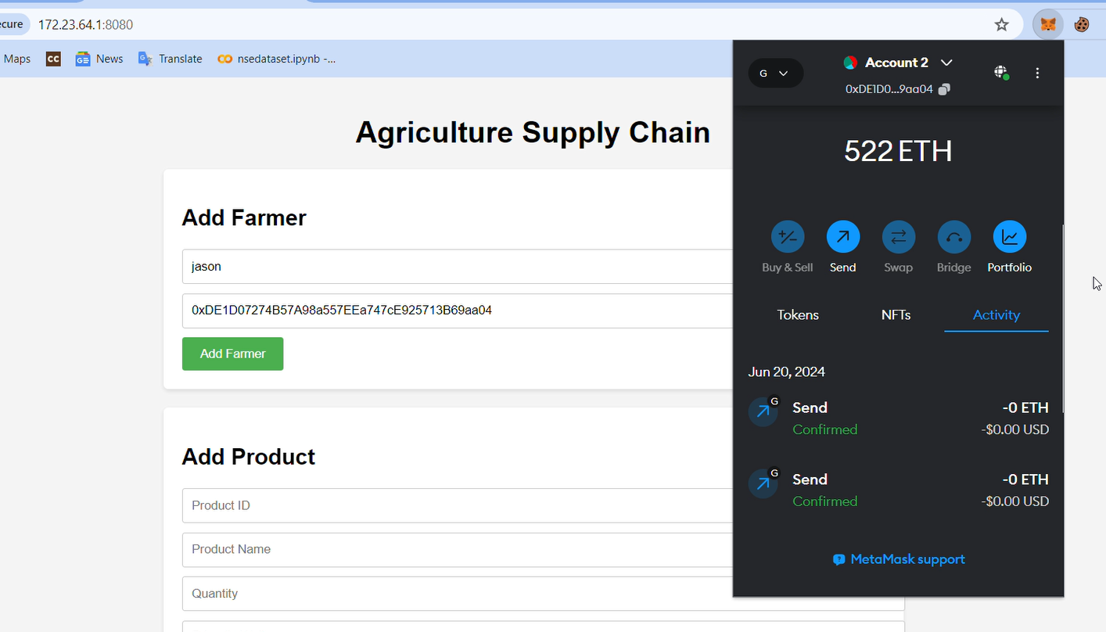

Above shows the result of integrating blockchain technology into the agriculture supply chain system. In this instance, a user named ”jason” is being added as a farmer, with their unique Ethereum address recorded on the blockchain. The web interface facilitates this process, and the MetaMask wallet extension confirms the transaction. The Ethereum balance and transaction history are displayed, indicating the successful addition of the farmer to the blockchain network,

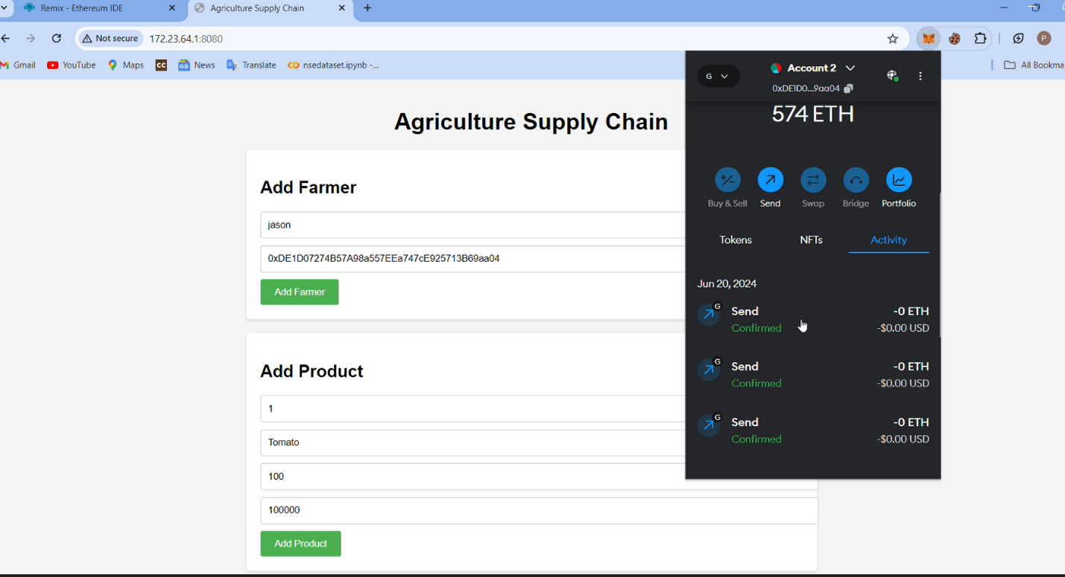

Above illustrates the process of adding a farmer and a product to the blockchain within an agriculture supply chain system. In this example, a user named ”jason” is added as a farmer, and a product, ”Tomato,” with specific details like product ID, quantity, and price, is also registered on the blockchain. The interface allows for these entries, and the MetaMask wallet extension shows the transaction confirmations, verifying that both the farmer and the product have been successfully added to the blockchain. This ensures the integrity and traceability of the supply chain data.

Above image illustrates A section titled ”Sell Product” allows users to specify the product ID and quantity to be sold. On the right, a cryptocurrency wallet is shown, displaying an account balance of 603 ETH and recent transaction activity, including confirmed sends. The secure nature of blockchain transactions is emphasized by the recorded activities, showcasing a confirmed transfer of 1 ETH. This setup ensures transparent and secure product sales leveraging blockchain technology . The fig 9 shows a blockchain-based platform with a section

The fig 9 shows a blockchain-based platform with a section Record Loss. specifically designed for recording post-harvest losses. This feature allows users to input the product ID and the quantity of loss after harvest. The recorded data ensures transparent and immutable tracking of post-harvest losses, leveraging the security and reliability of blockchain technology. This setup helps in accurately managing and auditing agricultural or product-related losses

**CONCLUSION**

The findings of this research underscore the immense potential of blockchain technology to revolutionize the agricultural supply chain and tackle post-harvest losses. By leveraging blockchain's decentralization, transparency, and immutability, a robust traceability system provides unprecedented visibility into the product journey. Smart contracts automate processes, streamlining coordination and reducing inefficiencies that contribute to losses. IoT integration enables real-time monitoring of environmental conditions, facilitating proactive spoilage prevention measures. Incentive mechanisms encourage sustainable practices, while advanced analytics identify bottlenecks and optimize logistics. Collectively, this blockchain-based approach enhances supply chain efficiency, curbs food loss, and promotes sustainability. Through transparency, automation, and data-driven decision-making, blockchain addresses the long-standing challenges of fragmented coordination and lack of visibility that exacerbate post-harvest losses. Ultimately, this innovative solution has the potential to significantly reduce waste, improve food security.

**REFERENCES**

[1]. Nakamoto, Satoshi. "Bitcoin: A peer-to-peer electronic cash system." (2008).

[2]. Wood, G. (2014). Ethereum: A Secure Decentralized Generalized Transaction Ledger.

[3]. Zyskind, G., Nathan, O., Pentland, A. (2015). Decentralizing Privacy: Using Blockchain to Protect Personal Data.

[4]. Buterin, V. (2013). Ethereum White Paper: A Next Generation Smart Contract Decentralized Application Platform.

[5]. Tsai, W.-T., Blower, R., Zhu, Y., Yu, L. (2016). A System View of Financial Blockchains. In Proceedings of the 2016 IEEE Symposium on Service-Oriented System Engineering (SOSE).

[6]. Mettler, M. (2016). Blockchain Technology in Healthcare: The Revolution Starts Here. In 2016 IEEE 18th International Conference on e-Health Networking, Applications and Services (Healthcom).

[7]. Fabio Fortuna, Mario Risso : Blockchain Technology in the Food Industry.

[8]. William George, Tareq Al-Ansari : Review of Blockchain Applications in Food Supply Chains